ASCII Characters
In Computers, everything is stored as a series of 0s and 1s. Storing numbers is quite easy, just convert them to binary and you are done.
But how characters are stored in the memory?
Computers can't directly store strings such as 'a', 'b', '1', '$' and so on in the memory. Instead, what they store is the numeric code that represent a character. A mapping of characters and their numeric codes is called ASCII (American Standard Code for Information Interchange) Character set. ASCII characters set has 128 characters.
In addition to the character found in the US keyboard, ASCII set also defines some control characters. Control characters are used to issue commands, they are non-printable characters.
An example of control character is Ctrl+D, which is commonly to terminate the shell window. This character in the ASCII table is represented using EOT (End-of-Transmission) and has an ASCII value of 4.
The following table shows all 128 characters in the ASCII Character set.
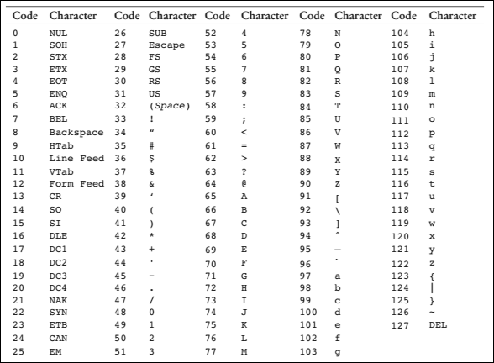
Here are a few things to notice:
- All the uppercase letters from A to Z have ASCII values from 65 to 90.
- All the lowercase letters from 'a' to 'z' have ASCII values from 97 to 122.
- When we uses digits (0-9) inside a string they are represented using ASCII values from 48 to 57.

